

Spirited Snowman Card Tutorial

Free with an order of $35.00 (before tax & shipping)

Spirited Snowman stamp set is required.

Kit includes items to create 4 cards,

use your ink and adhesive.


www.donnascreativespace.com

All Rights Stampin’ Up!

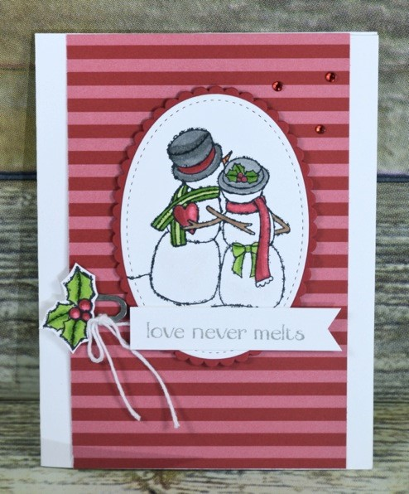

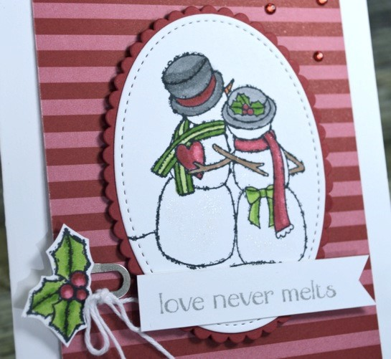

Supply List:

Stamps:
Spirited Snowman

Paper:
Whisper White, Real Red,
Thick Whisper White, Regals 6x6”
Designer Series Paper

Ink:
, Memento Black, Smoky
Slate

Embellishments:

Stampin’
Dimensionals, Red Rhinestones,
White Bakers Twine, Galvanized
Clips, Wink of Stella

Tools:

Big Shot, Layering Ovals
Framelits, Stitched Shape
Framelits, Smoky Slate Blends,
Pumpkin Pie Blends, Real Red
Blends, Granny Apple Green
Blends

Directions:

1.
Cut Thick Whisper White 5
½
x 8
½
” and fold. Cut the Real Red Striped DSP from the Regals
DSP Stack 5
½
x 3
½
” and la
yer.

2.
Stamp the snowmen onto Whisper White Cardstock in Memento Black Ink and cut out in the
Big Shot with the Stitched Shape Framelits. Cut out a Real Red Scallop Oval that layeres.

3.
Color in the snowman with the Stampin’ Blends with the Colors listed
above. Color in the
snow with Wink of Stella. Layer the Scallop Oval to the card with Stampin’ Dimensionals.

4.
Take the Galvanized Clip and attach a White Bakers Twine Bow. Clip onto the left side of the
DSP.

5.
Stamp the holly in Memento Black Ink onto a scap of Whisper White and fussy cut it out.
Color in the the Stampin’ Blends. Layer to the clip with Mini Glue Dots.

6.
Cut a Whisper White strip
½
x 2
½
” and stamp the sentiment in Smoky Slate Ink. Make the
en
d a banner and attach to the card.

7.
Sprinkle on Red Rhinestones.

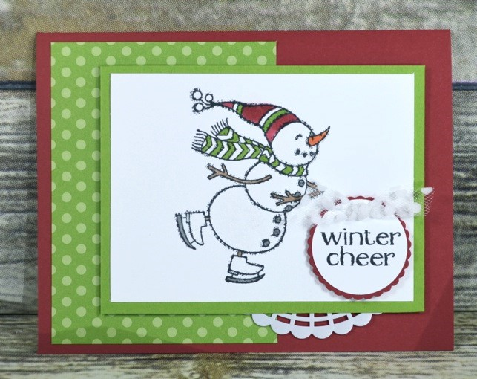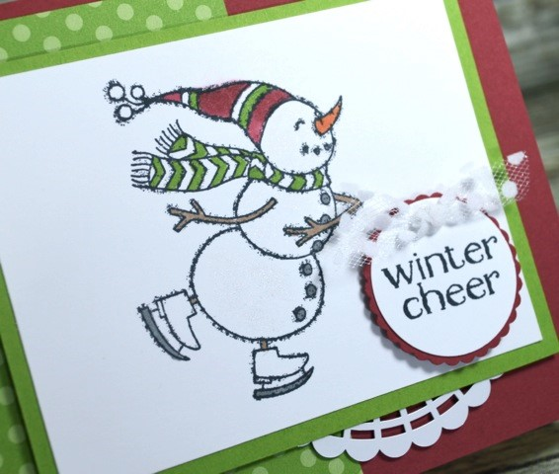

Supply List:

Stamps:
Spirited S
nowman

Paper:
Real Red, Whisper
White, Granny Apple Green,
Brights 6x6” Designer Series
Stack

Ink:

Memento Black

Embellishments:

Stampin’
Dimensionals, Mini Glue Dots,
Pearlized Doilies, White Polka
Dot Tulle Ribbon, Wink of
Stella

Tools:

1
-
3
/8” Scallop
Circle
Punch, 1
¼
” Circle Punch,
Real Red Stampin’ Blends,
Granny Apple Green
Stampin’ Blends, Pumpkin Pie
Stampin’ Blends, Smoky Slate
Stampin’ Blends, Bronze Blend

Directions:

1.
Cut Real Red 5
½
x 8
½
” and fold. Cut the granny Apple Green Brights DSP Stack 4x3”
and layer to the side. Cut Granny Apple Green Cardstock 4
¼
x 3
¼
”. Cut Whisper White
4
x3”.

2.
Stamp the snowman in Memento Black Ink onto the Whisper White. Color in wi
th the
Stampin’ Blends and the Wink of Stella for the snow. Cut half a Pearlized Doily and layer
to the back of the Granny Apple Green Cardstock and attach to the card with Stampin’
Dimensionals.

3.
Stamp the sentiment in Black Ink onto Whisper White and
Punch out with the 1
¼
” Circle
Punch. Layer to the 1
-
3
/8” Scallop Circle in Real Red. Attach with a Stampin’
Dimensional.

4.
Take the White Polka Dot Tulle and tie in a knot. Attach to the card with a Mini Glue Dot.

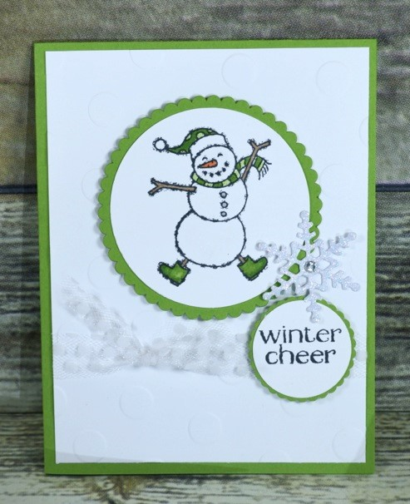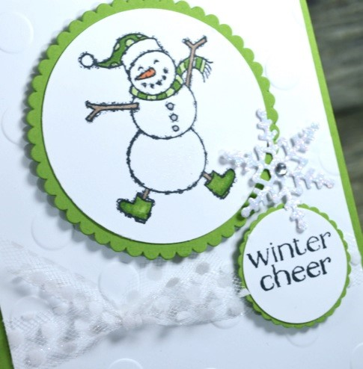
Supply List:

Stamps:
Spirited Snowman

Paper:
Granny Apple Green,
Whisper White,
Sparkle
Glimmer Paper

Ink:

Memento Black Ink

Embellishments:

Stampin’
Dimensionals, Mini Glue Dots,
Rhinestones, White Polka Dot
Tulle Ribbon, Wink of Stella

Tools:

Big Shot, Basic Polka Dot
Embossing Folder, Layering
Circle Framelits, 1
-
3
/8” Scallop
Circl
e, 1
¼
” Circle Punch,
Seasonal Tags Framelits

Directions:

1.

Cut
Granny Apple Green 5
½
x 8
½
” and fold. Cut Whisper White piece that is 5
¼
x 4”
and run through the Big Shot with the Polka Dot Embossing Folder and then wrap the Polka
Dot Tulle Ribbon
around and tie. Layer to the card.

2.
Stamp the snowman onto Whisper White with Memento Black Ink. Color him in with the
Stampin’ Blends and then Wink of Stella. Cut out with the Layering Circles Framelits in the
Big Shot. Cut out a layering Scallop Circ
le in Granny Apple Green also with those framelits
and then layer together. Attach to the card with Stampin’ DImensionals.

3.
Stamp the sentiment onto Whisper White Cardstock with Memento Black Ink and punch
out with the 1
-
1
/4” Circle Punch. Layer onto a
1
-
3
/8” Scallop Circle punched out with
Granny Apple Green. Attach with Stampin’ Dimensionals.

4.
Cut out a snowflake in Sparkle Glimmer Paper with the Seasonal Tags Framelits. Attach
with a Mini Glue Dot. Embelish the center with a Rhinestone.

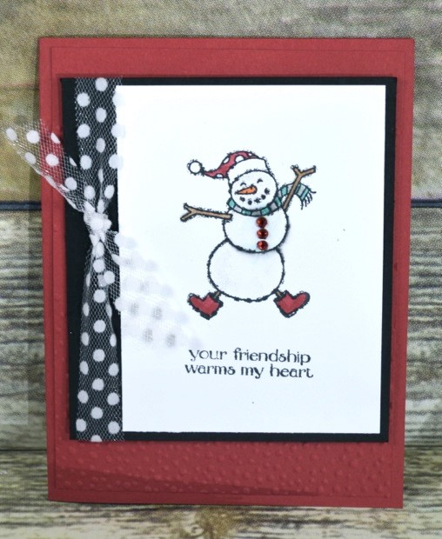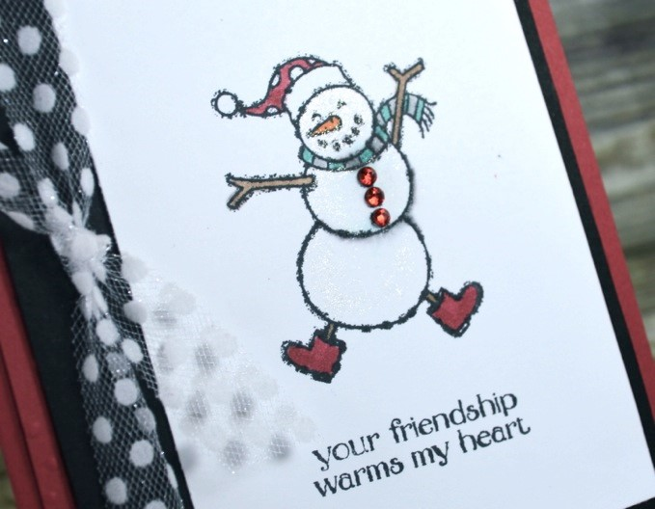
Directions:

1.

Cut Real Red 8
½
x 5
½
” and fold. Cut another piece that is 5
¼
x 4” and run it through
the Softly Falling Embossing Folder. Layer to the card.

2.
Cur Basic Black 3
¾
x

4
¼
” and wrap the Polka Dot Tulle Ribbon around the side and tie.

3.
Cut Whisper White C
ardstock 3x4” and stamp the snowman and sentiment in Memento
Black Ink. Color in the snowman with the Stampin’ Blends in the Supply List. Color in the
body with the Wink of Stella.

4.
Attach the Red Rhinestones to the snowman as buttons.

5.
Layer the Basic
Black to the card with Stampin’ Dimensionals.

Supply List:

Stamps:
Spirited Snowman

Paper:
Real Red, Whisper
White, Basic Black

Ink:

Memento Black Ink

Embellishments:

Stampin’
Dimensionals, Mini Glue Dots,
Red Rhinestones, White Polka
Dot Tulle Ribbon, Wink of Stella

Tools:

Big Shot, Softly Falling
E
mbossing Folder Cherry
Cobbler Stampin’ Blends,
Crumb Cake Stampin’ Blends,
Bermuda Bay Stampin’ Blends,
Smoky Slate Stampin’ Bends
,
Pumpkin Pie Stampin’ Blends

